**Systemic and mucosal immune response of Nile tilapia broodstock to monovalent and bivalent vaccine against bacteria *Streptococcus agalactiae* and *Aeromonas veronii*.**

By

Quentin Ludovic Stéphane ANDRES

A Thesis Submitted in Partial Fulfillment of the Requirements for the Degree of

Master of Science in Aquaculture and Aquatic Resources Management

Examination Committee: Name of Chairperson (Chairperson)

Committee Member

Committee Member

Nationality: French

Previous Degree: Bachelor of Molecular Biology, Microbiology

and Genetics

University of Nice – Côte d’Azur

Nice, France

Scholarship Donor: None

Asian Institute of Technology

School of Environment, Resources and Development

Thailand

April 2022

**AUTHOR’S DECLARATION**

I, Quentin ANDRES, declare that the research work carried out for this thesis was in accordance with the regulations of the Asian Institute of Technology. The work presented in it are my own and has been generated by me as the result of my own original research, and if external sources were used, such sources have been cited. It is original and has not been submitted to any other institution to obtain another degree or qualification. This is a true copy of the thesis, including final revisions.

Date: TBC

Name (in printed letters): Quentin ANDRES

Signature: TBC

**ACKNOWLEDGMENTS**

Type your acknowledgments here. This section is typically reserved for personal and professional dedications. You may also acknowledge your donor or funder here or include copyright acknowledgements of journals whose articles you have significantly incorporated in this thesis. Maintain one blank 1.5 line spacing between paragraphs.

[one page, maximum]

# ABSTRACT

Fighting bacterial infections inducing mass mortality in fish is a hot-topic research in the aquaculture field in order to be able to sustain its intensification. This research project is about developing monovalent and bivalent vaccines against the bacteria *Streptococcus agalactiae* and *Aeromonas veronii* to further administrate to fish Nile tilapia for which there is currently no existing vaccine available in Thailand. I intend to develop the vaccines using pathogen inactivation methods and later assess the immune response of the fish to the vaccine and its survivability after a challenge test with pathogen. This is a high-complexity and challenging research project I want to work on because I am passionate about fish health and vaccinology as well as cutting-edge technologies. To do so I will start with a bibliographic research on the methods and protocols that I will use during the experimentation. The first step of the research will be to prepare the experiment by stocking the Nile tilapia juveniles inside of the trial ponds prior to the start of the experiment. The fish will be stocked and in the meantime the vaccine will be produced from a culture of the bacteria in the laboratory. After recovering enough bacteria, the pathogens will be inactivated (=killed) using formalin. The latter step in the experiment will be the vaccine efficiency assessment trial and the study of the fish immune response from before the immunization to several weeks post immunization. Before the end of the experimentation, I will perform a challenge test in vivo on the juveniles. The ultimate part of the project will be to collect the results and communicate them to the community.

**CONTENTS**

**Page**

ACKNOWLEDGMENTS iii

ABSTRACT v

LIST OF TABLES ix

LIST OF FIGURES x

LIST OF ABBREVIATIONS xi

CHAPTER 1 INTRODUCTION 1

1.1 Background of the Study 1

1.2 Statement of the Problem 1

1.3 Proof of Concept 1

1.4 Hypothesis 1

1.5 Objectives of the Study 2

1.6 Risks and limitations 3

1.6.1 Project fundings 3

1.6.2 Access to Lab facilities 3

1.6.3 Risks in Experiments 3

1.7 Organization of the proof of concept development 3

1.7.1 Project plan 3

1.7.2 High level schedule 4

1.7.3 Collaborating research teams 5

1.7.4 Project fundings 5

CHAPTER 2 RELEVANT LITERATURE 7

2.1 Relevant literature on Carp Edema Virus Disease (CEVD) / Koi Sleepy Disease (KSD) 7

2.2 Relevant literature on mRNA vaccines 7

2.3 Relevant literature on low-cost experimental design 7

2.4 Chapter Summary 7

CHAPTER 3 METHODOLOGY AND RAW MATERIAL 9

3.1 High level view of the project steps 9

3.2 Methodology for STEP 1 9

3.3 Methodology for STEP 2 9

3.4 Methodology for STEP N 9

3.5 List of raw material 9

3.6 Price of raw material 9

3.7 Chapter Summary 9

CHAPTER 4 EXPERIMENTS AND RESULTS 11

4.1 Experiment #1 11

4.2 Experiment #2 11

4.3 *,* Chapter Summary 11

CHAPTER 5 CONCLUSION 12

REFERENCES 13

APPENDICES 14

APPENDIX A TITLE 15

APPENDIX B TITLE 16

VITA 17

# LIST OF TABLES

**Tables Page**

# LIST OF FIGURES

Figure 1 *Project plan* 4

Figure 2 *High level schedule* 5

Figure 3*. Illustration of steps involved in a possible route for the elaboration of a CEV mRNA candidate vaccine. The figures give a general workflow to the master research project.* 9

# LIST OF ABBREVIATIONS

|  |  |
| --- | --- |
| IVT | = In Vitro Transcribed |
| CEV | = Carp Edema Virus |
| KSD | = Koi Sleepy Disease |
|  |  |
|  |  |
|  |  |
|  |  |
|  |  |
|  |  |
|  |  |
|  |  |
|  |  |
|  |  |
|  |  |
|  |  |
|  |  |
|  |  |
|  |  |
|  |  |
|  |  |
|  |  |
|  |  |
|  |  |
|  |  |

# INTRODUCTION

## Background of the Study

The Carp Edema Virus disease (CEV), commonly called the Koi Sleepy Disease (KSD) has been identified for the first time in Japan in 1970 and has spread world-wide with more recent outbreaks in 2015-2018 in East-European countries and has re-emerged in Thailand and China in 2020 inducing mass mortality of fish (*Pikulkaew, S.; Phatwan, K.; Banlunara, W.; Intanon, M.; Bernard, J.K. First Evidence of Carp Edema Virus Infection of Koi Cyprinus carpio in Chiang Mai Province, Thailand. Viruses 2020, 12, 1400.)*.

## Statement of the Problem

In order to sustain an intensified cyprinid aquaculture, many research units and private companies around the world are studying immune responses of fish to viral infections and are experimenting with vaccines development. There is currently no existing vaccine against the CEV. In vitro transcribed messenger ribonucleic acids use as a prophylaxis treatment for aqua cultured freshwater fish has just started.

## Proof of Concept

The proof of concept I want to work on is the production of an In Vitro Transcribed mRNA vaccine against the CEV:

1. To protect Koi carps and common carps.
2. Using low-cost experimental designs as alternative techniques are widely used to cut production costs and there are tons of literature on those methods.

## Hypothesis

Even if literature is missing on CEV vaccine development, a lot of literature on IVT technologies for both Cancer and Infectious diseases are available online. The Tilapia lake virus (TiLV) but also the Influenza virus are two negative strand RNA viruses, and similarly to that of the CEV, some of the methods and protocols for the IVT but also the dynamics in the host/fish immunity response are likely to be the same.

Assumption that CEV and TiLV have a close molecular physiology and replicative mechanism can benefit me in the project because the literature of the latter is available.

My second assumption is the feasibility of the vaccine production using low-cost experimental design. Alternative techniques are widely used to cut production costs and there are tons of literature on those methods.

Last assumption is that it will always be possible to monitor the evolution of the process of production of the mRNA design. A framework will be followed according to the literature and to the outcomes of each steps.

## Objectives of the Study

The primary objective of this research project is to demonstrate that using simple molecular biology low-cost techniques, it is possible to recover some key genes or the full genome of the CEV via an infected sample, then to later clone those fully recovered sequences into a bioengineered bacterium. By the means of vector design via bioinformatics, the mRNA vaccine parts free of the candidate CEV gene and containing 2 cleaving/restriction enzyme sites will be designed.

The second objective is to set up a bacterial transcription platform holding the appropriate modifications in its plasmid genome (=The mRNA vaccine parts in the correct orientation relative to the promoter). This will allow me to easily and efficiently clone/insert any protein coding sequence of CEV recovered previously.

The more specific objective of this research project is to be able to produce the vaccine using low-cost experimental design, which will be more complex and challenging than out-sourcing the sequencing to a biotech company that will charge a lot of money, I don’t have, for de novo DNA synthesis. Many alternative techniques using low-cost PCR operations will be favored.

The last and ultimate objective is to deliver an efficacy-indicating study of the fish survival rate through challenge testing.

If I have time, I wish to monitor the viral infection in fish using a staining reporter such as Luciferase in vivo or using a fluorescent modified reporter Carp Edema Virus.

## Risks and limitations

### Project fundings

Even if I have the objective to use low-cost experimental design for the proof of concept, I would need to find some fundings. The cost of raw materials might be a limitation to the iterative process (test of several vaccine candidates/ failure in challenge tests?).

### Access to Lab facilities

I would need access to a lab facility to do the experiments and setting up the small bacterial vaccine production system, while PCR and all the activities relative to Carp culture, water analysis and preparation of the challenge test can be one at AIT. I need to access a simple microbiology laboratory, either in another department of the AIT or in a nearby university such as Thammasat Rangsit.

### Risks in Experiments

Culture of the bacteria and harvesting of virus might also not be simple but the risks will be mitigated with a good management.

## Organization of the proof of concept development

I expect to be able to set-up of a collaboration scheme with Chiang Mai research unit that has recently worked on the CEV in the last year. I would like them to provide me with virus sample, gene sequence, results of virus electrophoresis after a purification and digestion with restriction enzyme, and other valuable information.

### Project plan

I have broken down the project work in several phases as shown in Figure 1.

* Literature research
* Bioinformatics for the vector design and mRNA design.
* Culture and creation of the expression system.
* Final vaccine synthesis.
* IVT in vitro.
* IVT in vivo.
* Challenge tests and delivery of an efficacy-study based on fish survival rate.
* Communication of the results.

Figure 1 *Project plan*

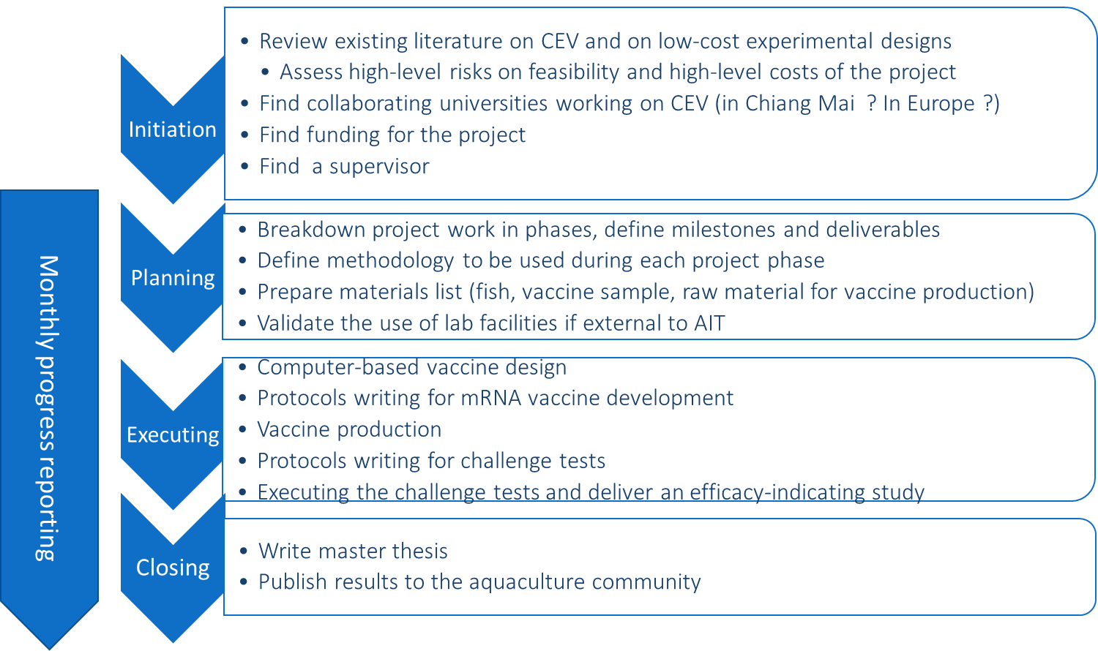

### High level schedule

The Figure 2 shows when I plan to work on the different activities of the different steps of the project.

Figure 2 *High level schedule*

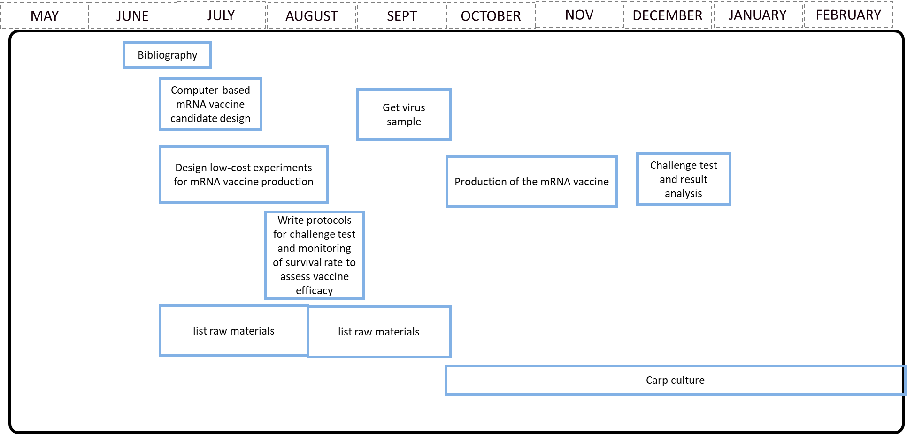

### Collaborating research teams

### Project fundings

# RELEVANT LITERATURE

TO BE DONE LATER This chapter will provide a review of the relevant literature the proof of concept development is based on. A first part will focus on the literature on the Carp Edema Virus, a second part on the literature on the mRNA vaccines and the last part will focus on the literature describing the low-cost experimental designs.

## Relevant literature on Carp Edema Virus Disease (CEVD) / Koi Sleepy Disease (KSD)

* *Shohreh Hesami, Pedro Viadanna et al.* [*https://edis.ifas.ufl.edu/pdf/FA/FA18900.pdf*](https://edis.ifas.ufl.edu/pdf/FA/FA18900.pdf)
* *Amita, K., M. Oe, H. Matoyama, N. Yamagushi, and H. Fukuda. 2002. "A survey of Koi herpes virus and carp edema virus in colorcarp cultured in Niigata Prefecture, Japan." Fish. Pathol. 37:197–8.*
* *Haenen, O., K. Way, D. Stone, and M. Engelsma. 2013. "Koi Sleepy Disease found for the first time in koi carps in the Netherlands." [in Dutch]. Tijdschr. Diergeneeskd. 5:27–29.*
* *Lewisch, E., B. Gorgoglione, K. Way, and M. El-Matbouli. 2015. "Carp edema virus/koi sleepy disease: An emerging disease in central-east Europe." Transbound Emerg Dis. 62:6–12.*

## Relevant literature on mRNA vaccines

* Pardi, N., Hogan, M., Porter, F. et al. mRNA vaccines — a new era in vaccinology. Nat Rev Drug Discov 17, 261–279 (2018). <https://doi.org/10.1038/nrd.2017.243>
* Gómez-Aguado, I.; Rodríguez-Castejón, J.; Vicente-Pascual, M.; Rodríguez-Gascón, A.; Solinís, M.Á.; del Pozo-Rodríguez, A. Nanomedicines to Deliver mRNA: State of the Art and Future Perspectives. *Nanomaterials* **2020**, *10*, 364. <https://doi.org/10.3390/nano10020364>

## Relevant literature on low-cost experimental design

* <https://pipettejockey.com/2019/11/22/teda-cloning-cheap-easy-gibson-alternative/>
* <https://pipettejockey.com/2020/02/05/t4-dna-ligase-plasmid-brought-to-you-by-chemically-incompetent/>
* <https://barricklab.org/twiki/bin/view/Lab/ProtocolList>

## Chapter Summary

# METHODOLOGY AND RAW MATERIAL

TO BE DONE LATER This chapter will describe the methodology used at each step of the proof of concept.

## High level view of the project steps

I will describe in the next paragraphs the methodology I will use for each of the steps described in Figure 3. TO BE CONTINUED

Figure 3*. Illustration of steps involved in a possible route for the elaboration of a CEV mRNA candidate vaccine. The figures give a general workflow to the master research project.*

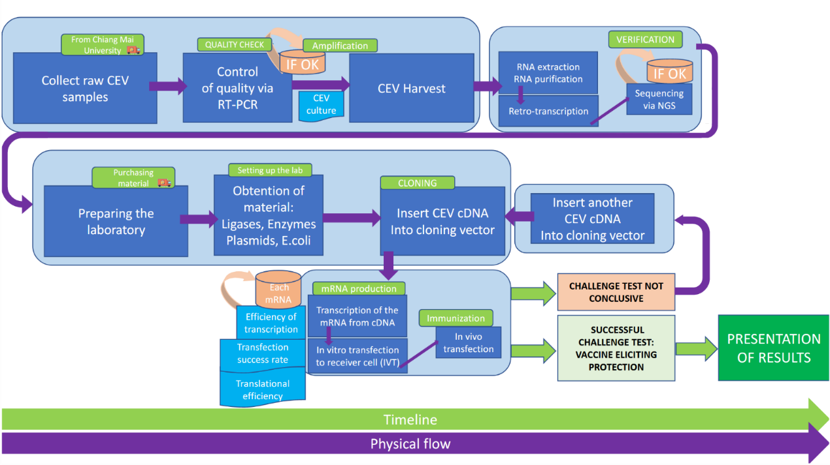

## Methodology for STEP 1

## Methodology for STEP 2

## Methodology for STEP N

## List of raw material

## Price of raw material

## Chapter Summary

# EXPERIMENTS AND RESULTS

TO BE DONE LATER This chapter will describe the experiments done.

## Experiment #1

## Experiment #2

….

## *,* Chapter Summary

# CONCLUSION

TO BE DONE LATER

# REFERENCES

# APPENDICES

APPENDIX A  
TITLE

Different materials are presented in the APPENDICES. Label the materials in the order that they are mentioned in the text or section (e.g., “see Appendix A for the questions”). Large or oversized tables or figures that support, but are not important in the text, are included in the appendices in a portrait or landscape orientation. This section is for a single table, figure, image, or illustration.

APPENDIX B  
TITLE

This section is for multiple tables and / or figures. You can also write a short description of this section.

**Table A1 Title**

Add the table here with proper formatting style.

**Table A2 Title**

Add the table here with proper formatting style.

**Figure A1 Title**

Add the figure here with proper formatting style.

**Figure A2**

Add the figure here with proper formatting style.

# VITA

This section presents a short description of the educational and professional achievements of the student.